7. A college marketing department has a networked storage device that uses the IP address 10.18.7.5, TCP port 443 for encryption, and UDP port 4365 for video streaming. The college already uses PAT on the router that connects to the Internet. The router interface has the public IP address of 209.165.200.225/30. The IP NAT pool currently uses the IP addresses ranging from 209.165.200.228-236. Which configuration would the network administrator add to allow this device to be accessed by the marketing personnel from home?

**ip nat inside source static tcp 10.18.7.5 443 209.165.200.225 443  
ip nat inside source static udp 10.18.7.5 4365 209.165.200.225 4365**

14. A **logical** topology influences the type of network framing and media access control that will be used.

22.A network administrator is adding ACLs to a new IPv6 multirouter environment. Which IPv6 ACE is automatically added implicitly at the end of an ACL so that two adjacent routers can discover each other?

**permit icmp any any nd-na**

45. A network administrator is designing an ACL. The networks 192.168.1.0/25, 192.168.0.0/25, 192.168.0.128/25, 192.168.1.128/26, and 192.168.1.192/26 are affected by the ACL. Which wildcard mask, if any, is the most efficient to use when specifying all of these networks in a single ACL permit entry?

0.0.0.127  
0.0.0.255  
**0.0.1.255**  
0.0.255.255

**46. A network administrator is explaining to a junior colleague the use of the lt and gt keywords when filtering packets using an extended ACL. Where would the lt or gt keywords be used?**

**in an IPv4 extended ACL that allows packets from a range of TCP ports destined for a specific network device**

.A network administrator is using the router-on-a-stick method to configure inter-VLAN routing. Switch port Gi1/1 is used to connect to the router. Which command should be entered to prepare this port for the task?

**Switch(config)# interface gigabitethernet 1/1  
Switch(config-if)# switchport mode trunk**

12. A network contains multiple VLANs spanning multiple switches. What happens when a device in VLAN 20 sends a broadcast Ethernet frame?  
**Only devices in VLAN 20 see the frame.**

8. A small-sized company has 20 workstations and 2 servers. The company has been assigned a group of IPv4 addresses 209.165.200.224/29 from its ISP. What technology should the company implement in order to allow the workstations to access the services over the Internet? DYNAMIC NAT

**9.A router has used the OSPF protocol to learn a route to the 172.16.32.0/19 network. Which command will implement a backup floating static route to this network?**

**ip route 172.16.32.0 255.255.224.0 S0/0/0 200**

A router needs to be configured to route within OSPF area 0. Which two commands are required to accomplish this? (Choose two.)

**RouterA(config)# router ospf 1**  
**RouterA(config-router)# network 192.168.2.0 0.0.0.255 area 0**

29. A small-sized company has 20 workstations and 2 servers. The company has been assigned a group of IPv4 addresses 209.165.200.224/29 from its ISP. What technology should the company implement in order to allow the workstations to access the services over the Internet?

**port address translation**

28 At a minimum, which address is required on IPv6-enabled interfaces?  
**link-local**

18. Consider the following range of addresses:  
2001:0DB8:BC15:00A0:0000::  
2001:0DB8:BC15:00A1:0000::  
2001:0DB8:BC15:00A2:0000::  
2001:0DB8:BC15:00AF:0000::

The prefix-length for the range of addresses is **/60**.

13. A network administrator is configuring access control to switch SW1. If the administrator uses console line to connect to the switch, which password is needed to access user EXEC mode?  
**lineconin**

9. A network administrator is explaining to a junior colleague the use of the **lt** and **gt** keywords when filtering packets using an extended ACL. Where would the **lt** or **gt** keywords be used?

**in an IPv4 extended ACL that allows packets from a range of TCP ports destined for a specific network device**

10. A network administrator is implementing a distance vector routing protocol between neighbors on the network. In the context of distance vector protocols, what is a neighbor?  
**routers that share a link and use the same routing protocol**

23. Can not connect to webpages, dns is ok.  
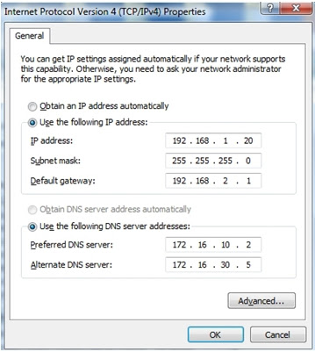  
Issue is: **Default Gateway**.

2.Fill in the blank.  
In IPv6, all routes are level **1** ultimate routes.

41. Fill in the blank.

Static routes are configured by the use of the **ip route** global configuration command.

42. Fill in the blank.

The default administrative distance for a static route is **1**.

4. Fill in the blank.  
The OSPF Type 1 packet is the **hello**​ packet.

16. How is the router ID for an OSPFv3 router determined?

**the highest IPv4 address on an active interface**

p1326. It will ask what is the issue.

Answer is:  
**The user has to be in privileged EXEC mode to use that command.**

24. It will give 4 options about ping, the correct one is: **The PC2 will be able to ping 192.168.1.1**

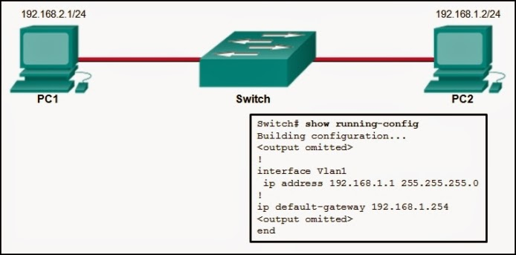

43. Match the order in which the link-state routing process occurs on a router. (Not all options are used.)  
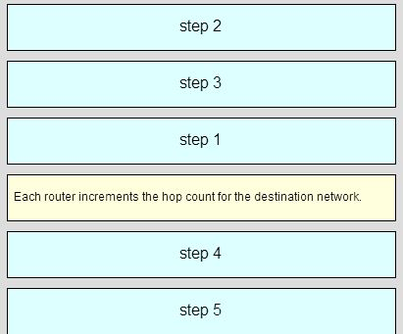

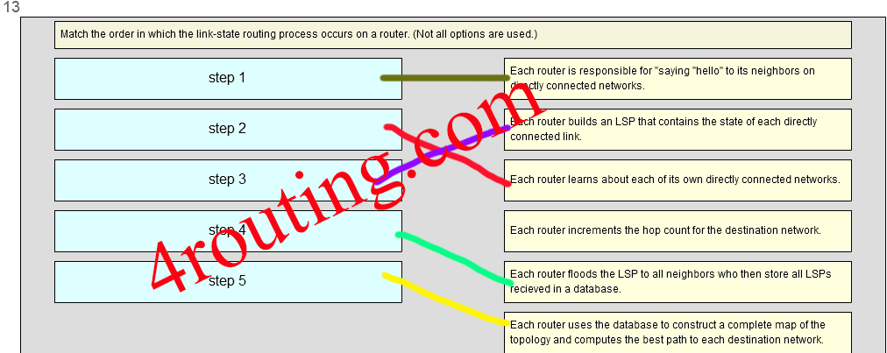platia čierne šípočky pre step1 a 2

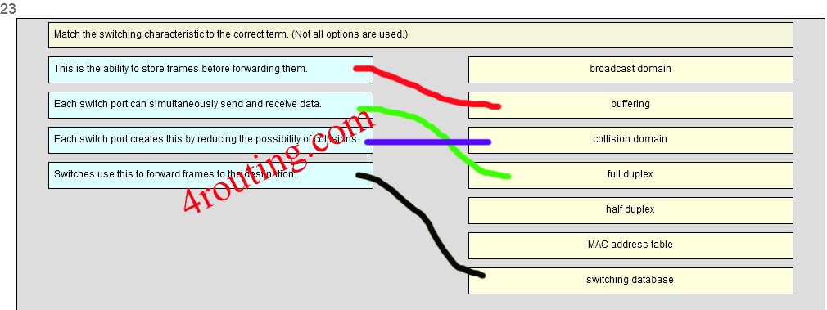

26.  
On a switch that is configured with multiple VLANs, which command will remove only VLAN 100 from the switch?

**Switch(config)# no vlan 100**

41. Open the PT Activity. Perform the tasks in the activity instructions and then answer the question.  
What is the problem preventing PC0 and PC1 from communicating with PC2 and PC3?

**The serial interfaces of the routers are in different subnets.**

56. Open the PT Activity. Perform the tasks in the activity instructions and then answer the question.

Which keyword is displayed on the web browser?

**Welldone!**

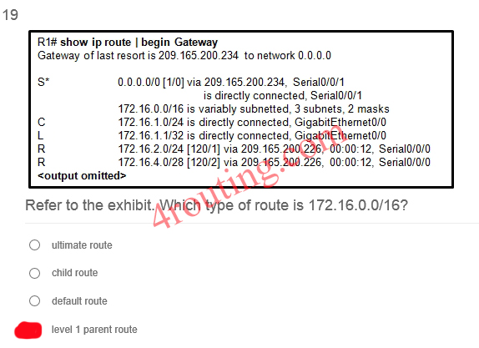

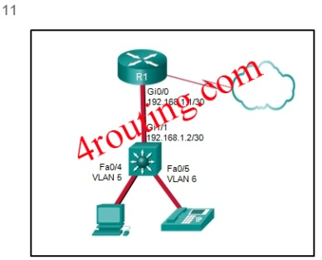11. Refer to the exhibit. A Layer 3 switch routes for three VLANs and connects to a router for Internet connectivity. Which two configurations would be applied to the switch? (Choose two.)

**(config)# interface gigabitethernet 1/1  
(config-if)# no switchport**

**(config)# ip routing**

[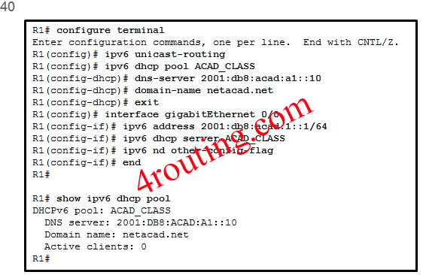](http://4routing.com/wp-content/uploads/2013/12/401.jpg)40. Refer to the exhibit. A network administrator is configuring a router as a DHCPv6 server. The administrator issues a show ipv6 dhcp pool command to verify the configuration. Which statement explains the reason that the number of active clients is 0?

**The state is not maintained by the DHCPv6 server under stateless DHCPv6 operation.**

9. Refer to the exhibit. A network administrator has just configured address translation and is verifying the configuration. What three things can the administrator verify? (Choose three.)  
  
[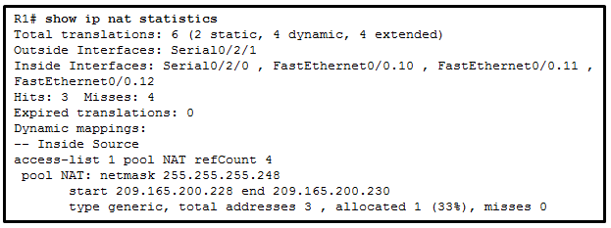](http://ccnav5.com/wp-content/uploads/2014/10/i215839v1n1_NAT.png)  
**A standard access list numbered 1 was used as part of the configuration process.**  
**Address translation is working.**  
**Two types of NAT are enabled.**

32. Refer to the exhibit. How did the router obtain the last route that is shown?  
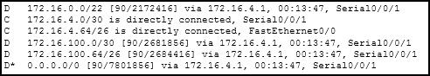  
**Another router in the same organization provided the default route by using a dynamic routing protocol.**

53. Refer to the exhibit. How many broadcast and collision domains exist in the topology?

[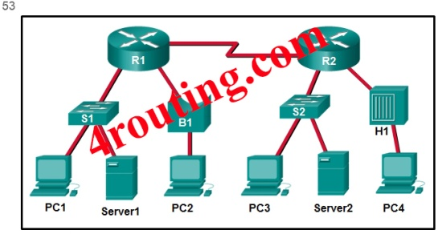](http://4routing.com/wp-content/uploads/2013/12/531.jpg)

**5 broadcast domains and 10 collision domains**

58. Refer to the exhibit. If RIPng is enabled, how many hops away does R1 consider the 2001:0DB8:ACAD:1::/64 network to be?

[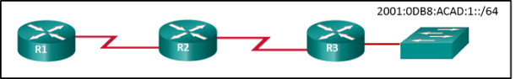](http://4routing.com/wp-content/uploads/2013/12/i215852v1n1_215852v3.png)

**3**

[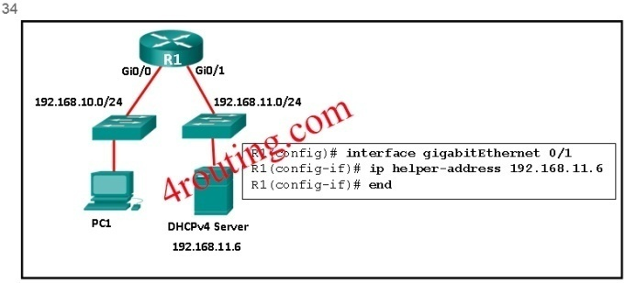](http://4routing.com/wp-content/uploads/2013/12/341.jpg)34. Refer to the exhibit. R1 has been configured as shown. However, PC1 is not able to receive an IPv4 address. What is the problem?

R1 is not configured as a DHCPv4 server.  
A DHCP server must be installed on the same LAN as the host that is receiving the IP address.  
The ip address dhcp command was not issued on the interface Gi0/1.  
**The ip helper-address command was applied on the wrong interface.**

[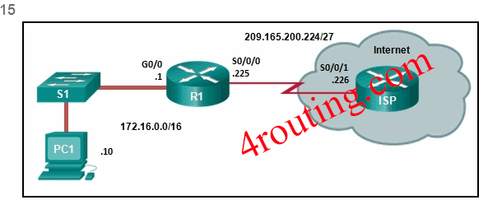](http://4routing.com/wp-content/uploads/2013/12/151.jpg)15.__ Refer to the exhibit. R1 was configured with the static route command ip route 209.165.200.224 255.255.255.224 S0/0/0 and consequently users on network 172.16.0.0/16 are unable to reach resources on the Internet. How should this static route be changed to allow user traffic from the LAN to reach the Internet?  
  
  
**Change the destination network and mask to 0.0.0.0 0.0.0.0.0.**

[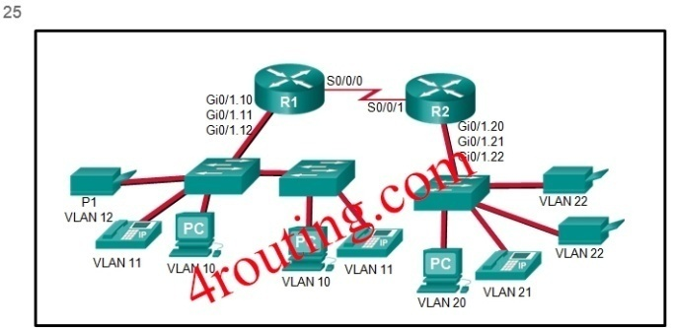](http://4routing.com/wp-content/uploads/2013/12/251.jpg)25. Refer to the exhibit. The Gigabit interfaces on both routers have been configured with subinterface numbers that match the VLAN numbers connected to them. PCs on VLAN 10 should be able to print to the P1 printer on VLAN 12. PCs on VLAN 20 should print to the printers on VLAN 22. What interface and in what direction should you place a standard ACL that allows printing to P1 from data VLAN 10, but stops the PCs on VLAN 20 from using the P1 printer? (Choose two.)

**outbound**  
**R1 Gi0/1.12**

[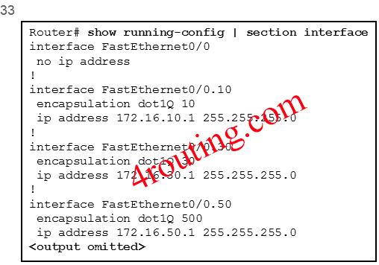](http://4routing.com/wp-content/uploads/2013/12/331.jpg)

33. Refer to the exhibit. The partial configuration that is shown was used to configure router on a stick for VLANS 10, 30, and 50. However, testing shows that there are some connectivity problems between the VLANs. Which configuration error is causing this problem?

**The wrong VLAN has been configured on subinterface Fa0/0.50.**

[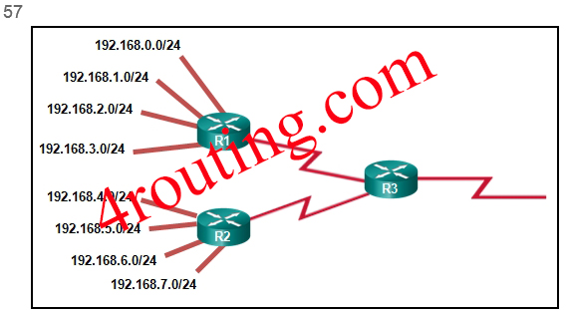](http://4routing.com/wp-content/uploads/2013/12/571.jpg)

57. Refer to the exhibit.

What summary static address would be configured on R1 to advertise to R3?  
**192.168.0.0/22**

34. Refer to the exhibit. Which type of IPv6 static route is configured in the exhibit?  
4  
**recursive static route**

33. Refer to the exhibit. Which type of route is 172.16.0.0/16?  
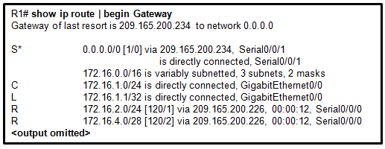  
**level 1 parent route**

22 **TFTP** is a best-effort, connectionless application layer protocol that is used to transfer files.

5. The computers used by the network administrators for a school are on the 10.7.0.0/27 network. Which two commands are needed at a minimum to apply an ACL that will ensure that only devices that are used by the network administrators will be allowed Telnet access to the routers? (Choose two.)  
**ip access-group 5 in  
access-list 5 permit 10.7.0.0 0.0.0.31**

25. The question is from where is the system image being loaded. Answer: **flash**.

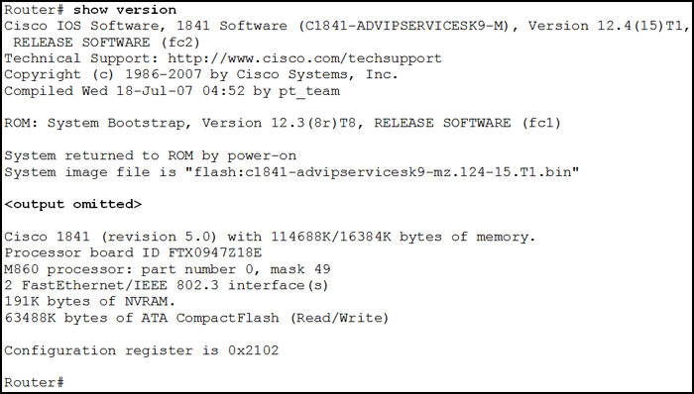

17. Two employees in the Sales department work different shifts with their laptop computers and share the same Ethernet port in the office. Which set of commands would allow only these two laptops to use the Ethernet port and create violation log entry without shutting down the port if a violation occurs?

**switchport mode access  
switchport port-security  
switchport port-security maximum 2  
switchport port-security mac-address sticky  
switchport port-security violation restrict**

6. What address type will OSPFv3 use to form adjacency to neighboring routers?  
the all-link router multicast  
the all OSPF router multicast  
the global unicast of the interface  
the link-local address of the interface

27. What are three characteristics of multicast transmission? (Choose three.)

**A single packet can be sent to a group of hosts.  
Multicast messages map lower layer addresses to upper layer addresses.  
Multicast transmission can be used by routers to exchange routing information.**  
1.What are two features of a link-state routing protocol? (Choose two.)  
**Routers send triggered updates in response to a change.  
Routers create a topology of the network by using information from other routers.**

38. What are two ways of turning off DTP on a trunk link between switches? (Choose two.)

**Configure attached switch ports with the nonegotiate command option.**  
**Place the two attached switch ports in access mode.**

48.What benefit does NAT64 provide?

**It allows sites to connect IPv6 hosts to an IPv4 network by translating the IPv6 addresses to IPv4 addresses.**

35.What best describes the operation of distance vector routing protocols?

**They send their routing tables to directly connected neighbors.**

20.What caused the following error message to appear?

01:11:12: %PM-4-ERR_DISABLE: psecure-violation error detected on Fa0/8, putting Fa0/8 in err-disable state  
01:11:12: %PORT_SECURITY-2-PSECURE_VIOLATION: Security violation occurred, caused by MAC address 0011.a0d4.12a0 on port FastEthernet0/8.  
01:11:13: %LINEPROTO-5-UPDOWN: Line protocol on Interface FastEthernet0/8, changed state to down  
01:11:14: %LINK-3-UPDOWN: Interface FastEthernet0/8, changed state to down

**Port security was enabled on the switch port, and an unauthorized connection was made on switch port Fa0/8.**

24.What does the cost of an OSPF link indicate?  
**A lower cost indicates a better path to the destination than a higher cost does.**

47. What happens immediately after two OSPF routers have exchanged hello packets and have formed a neighbor adjacency?

**They exchange abbreviated lists of their LSDBs**

32. What is a disadvantage of NAT?

**There is no end-to-end addressing.**

28.What is a function of the distribution layer?

**interconnection of large-scale networks in wiring closets**

12. What is the protocol that is used to discover a physical address from a known logical address and what message type does it use?  
**ARP, broadcast**

40. What is the purpose of an access list that is created as part of configuring IP address translation?

**The access list defines the private IP addresses that are to be translated.**

49. What is the purpose of setting the native VLAN separate from data VLANs?

**A separate VLAN should be used to carry uncommon untagged frames to avoid bandwidth contention on data VLANs.**

19 What three application layer protocols are part of the TCP/IP protocol suite? (Choose three.)  
**FTP**  
**DHCP**  
**DNS**

6. When a Cisco switch receives untagged frames on a 802.1Q trunk port, which VLAN ID is the traffic switched to by default?

**native VLAN ID**

38. When configuring a switch to use SSH for virtual terminal connections, what is the purpose of the crypto key generate rsa command?

**create a public and private key pair**

20 Which communication tool allows real-time collaboration?  
**instant messaging**

50. Which command, when issued in the interface configuration mode of a router, enables the interface to acquire an IPv4 address automatically from an ISP, when that link to the ISP is enabled?

**ip address dhcp**

[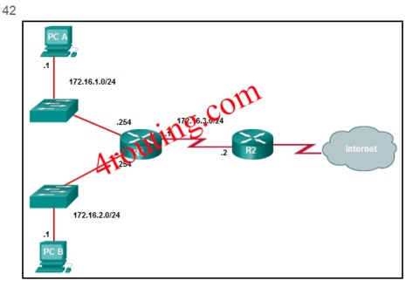](http://4routing.com/wp-content/uploads/2013/12/421.jpg)**42.** Which command will create a static route on R2 in order to reach PC B?

**R1(config)# ip route 172.16.2.0 255.255.255.0 172.16.3.1**

2. Which command will enable auto-MDIX on a device?  
**S1(config-if)# mdix auto**

17. Which firewall technique blocks incoming packets unless they are responses to internal requests?  
**stateful packet inspection**

29 Which frame forwarding method receives the entire frame and performs a CRC check to detect errors before forwarding the frame?  
**store-and-forward switching**

39.Which information does a switch use to populate the MAC address table?

**the source MAC address and the incoming port**

46.Which kind of message is sent by a DHCP client when its IP address lease has expired?

**a DHCPREQUEST unicast message**

21 Which of the following are primary functions of a router? (Choose two.)  
**packet switching**  
**path selection**

31. Which one of source IPv4 addresses is translated by R1 with PAT?

The computers used by the network administrators for a school are on the 10.7.0.0/27 network. Which two commands are needed at a minimum to apply an ACL that will ensure that only devices that are used by the network administrators will be allowed Telnet access to the routers? (Choose two.)

**access-class 5 in**  
**access-list 5 permit 10.7.0.0 0.0.0.31**

43. Which problem is evident if the show ip interface command shows that the interface is down and the line protocol is down?

**A cable has not been attached to the port.**

8. Which statement describes a route that has been learned dynamically?

**It is automatically updated and maintained by routing protocols.**

51. Which statement is correct about IPv6 routing?

**IPv6 uses the link-local address of neighbors as the next-hop address for dynamic routes.**

35. Which statement is true about the difference between OSPFv2 and OSPFv3?

**OSPFv3 routers do not need to have matching subnets to form neighbor adjacencies.**

4.Which summary IPv6 static route statement can be configured to summarize only the routes to networks 2001:db8:cafe::/58 through 2001:db8:cafe:c0::/58?

**ipv6 route 2001:db8:cafe::/56 S0/0/0**

3.Which switching method drops frames that fail the FCS check?

**store-and-forwardswitching**

37. Which three advantages are provided by static routing? (Choose three.)

**The path a static route uses to send data is known.**  
**Static routing does not advertise over the network, thus providing better security.**  
**Static routing typically uses less network bandwidth and fewer CPU operations than dynamic routing does.**

37. Which three pairs of trunking modes will establish a functional trunk link between two Cisco switches? (Choose three.)

**dynamic desirable – dynamic desirable**  
**dynamic desirable – dynamic auto  
dynamic desirable – trunk**

3. Which three parameters could be in an extended access control list? (Choose three.)  
**destination address and wildcard mask**  
**source address and wildcard mask**  
**access list number between 100 and 199**

31. Which three pieces of information does a link-state routing protocol use initially as link-state information for locally connected links? (Choose three.)

**the cost of that link**  
**the type of network link**  
**the link router interface IP address and subnet mask**

30. Which three requirements are necessary for two OSPFv2 routers to form an adjacency? (Choose three.)

**The link interface subnet masks must match.**  
**The two routers must include the inter-router link network in an OSPFv2 network command.**  
**The OSPF hello or dead timers on each router must match.**

44. Which three values or sets of values are included when creating an extended access control list entry? (Choose three.)

**access list number between 100 and 199**  
**source address and wildcard mask**  
**destination address and wildcard mask**

54. Which two commands can be used to verify the content and placement of access control lists? (Choose two.)

**show access-lists**  
**show running-config**

1. Which two commands should be implemented to return a Cisco 3560 trunk port to its default configuration? (Choose two.)  
**S1(config-if)# no switchport trunk native vlan**  
**S1(config-if)# no switchport trunk allowed vlan**

18.  
Which two factors are important when deciding which interior gateway routing protocol to use? (Choose two.)

**speed of convergence**

**scalability**

39. Which two characteristics describe the native VLAN? (Choose two.)

**The native VLAN traffic will be untagged across the trunk link.**  
**The native VLAN provides a common identifier to both ends of a trunk.**

11. Which two methods can be used to provide secure management access to a Cisco switch? (Choose two.)  
**Configure SSH for remote management.  
Configure specific ports for management traffic on a specific VLAN.**

14. Which two packet filters could a network administrator use on an IPv4 extended ACL? (Choose two.)  
**ICMP message type  
destination UDP port number**

16. Which two protocols function at the internet layer? (Choose two.)  
**ICMP**  
**IP**

8. Which two statements are true about half-duplex and full-duplex communications? (Choose two.)  
**Full duplex offers 100 percent potential use of the bandwidth.  
Full duplex allows both ends to transmit and receive simultaneously.**

15. Which two statements describe the characteristics of fiber-optic cabling? (Choose two.)  
**Fiber-optic cabling does not conduct electricity.**  
**Fiber-optic cabling is primarily used as backbone cabling.**

21. Which two statements are characteristics of routed ports on a multilayer switch? (Choose two.)

**They are used for point-to-multipoint links.  
They are not associated with a particular VLAN.**

55. Which type of traffic would most likely have problems when passing through a NAT device?

**IPsec**

36. While analyzing log files, a network administrator notices reoccurring native VLAN mismatches. What is the effect of these reoccurring errors?

**The control and management traffic on the error-occurring trunk port is being misdirected or dropped.**

7. Why would an administrator use a network security auditing tool to flood the switch MAC address table with fictitious MAC addresses?  
**to determine which ports are not correctly configured to prevent MAC address flooding**

**Which value represents the “trustworthiness” of a route and is used to determine which route to install into the routing table when there are multiple routes toward the same destination?**

**administrative distance\***

**Refer to the exhibit. If the switch reboots and all routers have to re-establish OSPF adjacencies, which routers will become the new DR and BDR?**

**Router R4 will become the DR and router R3 will become the BDR.\***

What is the minimum configuration for a router interface that is participating in IPv6 routing?

**to have only a link-local IPv6 address**

Refer to the exhibit. How did the router obtain the last route that is shown?

**Another router in the same organization provided the default route by using a dynamic routing protocol.**

A network administrator is designing an ACL. The networks 192.168.1.0/25, 192.168.0.0/25, 192.168.0.128/25, 192.168.1.128/26, and 192.168.1.192/26 are affected by the ACL. Which wildcard mask, if any, is the most efficient to use when specifying all of these networks in a single ACL permit entry?

**0.0.1.255**

Why would an administrator use a network security auditing tool to flood the switch MAC address table with fictitious MAC addresses?

**to determine which ports are not correctly configured to prevent MAC address flooding**

Refer to the exhibit. A Layer 3 switch routes for three VLANs and connects to a router for Internet connectivity. Which two configurations would be applied to the switch? (Choose two.)

**1. (config)# interface gigabitethernet 1/1   
(config-if)# no switchport   
(config-if)# ip address 192.168.1.2 255.255.255.252**  
**2. (config)# ip routing**

Which two statements are true about half-duplex and full-duplex communications? (Choose two.)

**1. Full duplex offers 100 percent potential use of the bandwidth.  
  
2. Full duplex allows both ends to transmit and receive simultaneously.**

A network administrator is explaining to a junior colleague the use of the lt and gt keywords when filtering packets using an extended ACL. Where would the lt or gt keywords be used?

**in an IPv4 extended ACL that allows packets from a range of TCP ports destined for a specific network device**

Fill in the blank.  
In IPv6, all routes are level ultimate routes.

**1**

A network administrator is using the router-on-a-stick method to configure inter-VLAN routing. Switch port Gi1/1 is used to connect to the router. Which command should be entered to prepare this port for the task?

**Switch(config)# interface gigabitethernet 1/1   
Switch(config-if)# switchport mode trunk**

### Refer to the exhibit. R1 was configured with the static route command ip route 209.165.200.224 255.255.255.224 S0/0/0 and consequently users on network 172.16.0.0/16 are unable to reach resources on the Internet. How should this static route be changed to allow user traffic from the LAN to reach the Internet?

Change the destination network and mask to 0.0.0.0 0.0.0.0.0.

### Refer to the exhibit. Which type of route is 172.16.0.0/16?

level 1 parent route

### A network contains multiple VLANs spanning multiple switches. What happens when a device in VLAN 20 sends a broadcast Ethernet frame?

Only devices in VLAN 20 see the frame.

### Fill in the blank. The acronym describes the type of traffic that has strict QoS requirements and utilizes a one-way overall delay less than 150 ms across the network.

VoIP

### Match the switching characteristic to the correct term. (Not all options are used.) A. This is the ability to store frames before forwarding them. B. Each switch port can simultaneously send and receive data. C. Each switch port creates this by reducing the possibility of collisions D. Switches use this to forward frames to the destination

1. broadcast domain  
  
2. buffering - A  
  
3. collision domain - C  
  
4. full duplex - B  
  
5. half duplex  
  
6. MAC address table  
  
7. switching database - D

### What benefit does NAT64 provide?

It allows sites to connect IPv6 hosts to an IPv4 network by translating the IPv6 addresses to IPv4 addresses.

### What is a disadvantage of NAT?

There is no end-to-end addressing.

### Refer to the exhibit. The Gigabit interfaces on both routers have been configured with subinterface numbers that match the VLAN numbers connected to them. PCs on VLAN 10 should be able to print to the P1 printer on VLAN 12. PCs on VLAN 20 should print to the printers on VLAN 22. What interface and in what direction should you place a standard ACL that allows printing to P1 from data VLAN 10, but stops the PCs on VLAN 20 from using the P1 printer? (Choose two.)

1. outbound  
2. R1 Gi0/1.12

### Two employees in the Sales department work different shifts with their laptop computers and share the same Ethernet port in the office. Which set of commands would allow only these two laptops to use the Ethernet port and create violation log entry without shutting down the port if a violation occurs?

switchport mode access  
switchport port-security  
switchport port-security maximum 2  
switchport port-security mac-address sticky  
switchport port-security violation restrict

### Which command will create a static route on R2 in order to reach PC B?

R1(config)# ip route 172.16.2.0 255.255.255.0 172.16.3.1

### Refer to the exhibit. The partial configuration that is shown was used to configure router on a stick for VLANS 10, 30, and 50. However, testing shows that there are some connectivity problems between the VLANs. Which configuration error is causing this problem?

The wrong VLAN has been configured on subinterface Fa0/0.50.

### Which three pieces of information does a link-state routing protocol use initially as link-state information for locally connected links? (Choose three.)

1. the cost of that link   
  
2. the type of network link   
  
3. the link router interface IP address and subnet mask

### Which switching method drops frames that fail the FCS check?

store-and-forward switching

### Which two commands should be implemented to return a Cisco 3560 trunk port to its default configuration? (Choose two.)

1. S1(config-if)# no switchport trunk native vlan  
  
2. S1(config-if)# no switchport trunk allowed vlan

### Which command will enable auto-MDIX on a device?

S1(config-if)# mdix auto

### What is the effect of issuing the passive-interface default command on a router that is configured for OSPF?

It prevents OSPF messages from being sent out any OSPF-enabled interface.

### Which two packet filters could a network administrator use on an IPv4 extended ACL? (Choose two.)

1. ICMP message type  
  
2. destination UDP port number

### What is the purpose of setting the native VLAN separate from data VLANs?

A separate VLAN should be used to carry uncommon untagged frames to avoid bandwidth contention on data VLANs.

### Which three advantages are provided by static routing? (Choose three.)

1. The path a static route uses to send data is known.  
  
2. Static routing does not advertise over the network, thus providing better security.   
  
3. Static routing typically uses less network bandwidth and fewer CPU operations than dynamic routing does.

### A network administrator is implementing a distance vector routing protocol between neighbors on the network. In the context of distance vector protocols, what is a neighbor?

routers that share a link and use the same routing protocol

### Refer to the exhibit. How many broadcast and collision domains exist in the topology?

5 broadcast domains and 10 collision domains

### Which command, when issued in the interface configuration mode of a router, enables the interface to acquire an IPv4 address automatically from an ISP, when that link to the ISP is enabled?

ip address dhcp

### A college marketing department has a networked storage device that uses the IP address 10.18.7.5, TCP port 443 for encryption, and UDP port 4365 for video streaming. The college already uses PAT on the router that connects to the Internet. The router interface has the public IP address of 209.165.200.225/30. The IP NAT pool currently uses the IP addresses ranging from 209.165.200.228-236. Which configuration would the network administrator add to allow this device to be accessed by the marketing personnel from home?

ip nat inside source static tcp 10.18.7.5 443 209.165.200.225 443  
ip nat inside source static udp 10.18.7.5 4365 209.165.200.225 4365

### How is the router ID for an OSPFv3 router determined?

the highest IPv4 address on an active interface

### Which two factors are important when deciding which interior gateway routing protocol to use? (Choose two.)

1. speed of convergence  
  
2. scalability

### A network administrator is adding ACLs to a new IPv6 multirouter environment. Which IPv6 ACE is automatically added implicitly at the end of an ACL so that two adjacent routers can discover each other?

permit icmp any any nd-na

### Refer to the exhibit. A network administrator is configuring a router as a DHCPv6 server. The administrator issues a show ipv6 dhcp pool command to verify the configuration. Which statement explains the reason that the number of active clients is 0?

The state is not maintained by the DHCPv6 server under stateless DHCPv6 operation.

### Which statement is correct about IPv6 routing?

IPv6 uses the link-local address of neighbors as the next-hop address for dynamic routes.

### A router has used the OSPF protocol to learn a route to the 172.16.32.0/19 network. Which command will implement a backup floating static route to this network?

ip route 172.16.32.0 255.255.224.0 S0/0/0 200

### Which three values or sets of values are included when creating an extended access control list entry? (Choose three.)

1. access list number between 100 and 199   
  
2. source address and wildcard mask   
  
3. destination address and wildcard mask

### Which two statements are characteristics of routed ports on a multilayer switch? (Choose two.)​

1. They are used for point-to-multipoint links.  
  
2. They are not associated with a particular VLAN.

### Refer to the exhibit. If RIPng is enabled, how many hops away does R1 consider the 2001:0DB8:ACAD:1::/64 network to be?

3

### A small-sized company has 20 workstations and 2 servers. The company has been assigned a group of IPv4 addresses 209.165.200.224/29 from its ISP. What technology should the company implement in order to allow the workstations to access the services over the Internet?

dynamic NAT

### Refer to the exhibit. A network administrator has just configured address translation and is verifying the configuration. What three things can the administrator verify? (Choose three.)

1. The name of the NAT pool is refCount.  
  
2. A standard access list numbered 1 was used as part of the configuration process.  
  
3. Address translation is working.



### Refer to the exhibit. R1 has been configured as shown. However, PC1 is not able to receive an IPv4 address. What is the problem?​

The ip helper-address command was applied on the wrong interface.

### Which statement is true about the difference between OSPFv2 and OSPFv3?

OSPFv3 routers do not need to have matching subnets to form neighbor adjacencies.

### The computers used by the network administrators for a school are on the 10.7.0.0/27 network. Which two commands are needed at a minimum to apply an ACL that will ensure that only devices that are used by the network administrators will be allowed Telnet access to the routers? (Choose two.)

1. access-list 5 permit 10.7.0.0 0.0.0.31  
  
2. access-class 5 in

### Fill in the blank. The OSPF Type 1 packet is the ​ packet.

hello

### When a Cisco switch receives untagged frames on a 802.1Q trunk port, which VLAN ID is the traffic switched to by default?

native VLAN ID

### Match the router memory type that provides the primary storage for the router feature. (Not all options are used.) A. flash B. NVRAM C. RAM D. ROM

1. console access  
  
2. full operating system - A  
  
3. limited operating system - D  
  
4. routing table - C  
  
5. startup configuration file - B

### What happens immediately after two OSPF routers have exchanged hello packets and have formed a neighbor adjacency?

They exchange abbreviated lists of their LSDBs.

### Which type of traffic would most likely have problems when passing through a NAT device?

IPsec

### What does the cost of an OSPF link indicate?

A lower cost indicates a better path to the destination than a higher cost does.

### Which information does a switch use to populate the MAC address table?

the source MAC address and the incoming port

### Match the order in which the link-state routing process occurs on a router. (Not all options are used.) A. step 1 B. step 2 C. step 3 D. step 4 E. step 5

1. Each router is responsible for "saying hello" to its neighbors on directly connected networks. - B  
  
2. Each router builds a Link-State Packet (LSP) containing the state of each directly connected link - C  
  
3. Each router learns about its own directly connected networks. - A  
  
4. Each router increments the hop count for the destination network.  
  
5. Each router floods the LSP to all neighbors, who then store all LSPs received in a database - D  
  
6. Each router uses the database to construct a complete map of the topology and computes the best - E

### Which two methods can be used to provide secure management access to a Cisco switch? (Choose two.)

1. Configure specific ports for management traffic on a specific VLAN.  
  
2. Configure SSH for remote management.

### Which kind of message is sent by a DHCP client when its IP address lease has expired?​

a DHCPREQUEST unicast message​

### Which three requirements are necessary for two OSPFv2 routers to form an adjacency? (Choose three.)

1. The link interface subnet masks must match.   
  
2. The two routers must include the inter-router link network in an OSPFv2 network command.   
  
3. The OSPF hello or dead timers on each router must match.

**1 Which command would be best to use on an unused switch port if a company adheres to the best practices as recommended by Cisco?**  
**shutdown\***

**2**

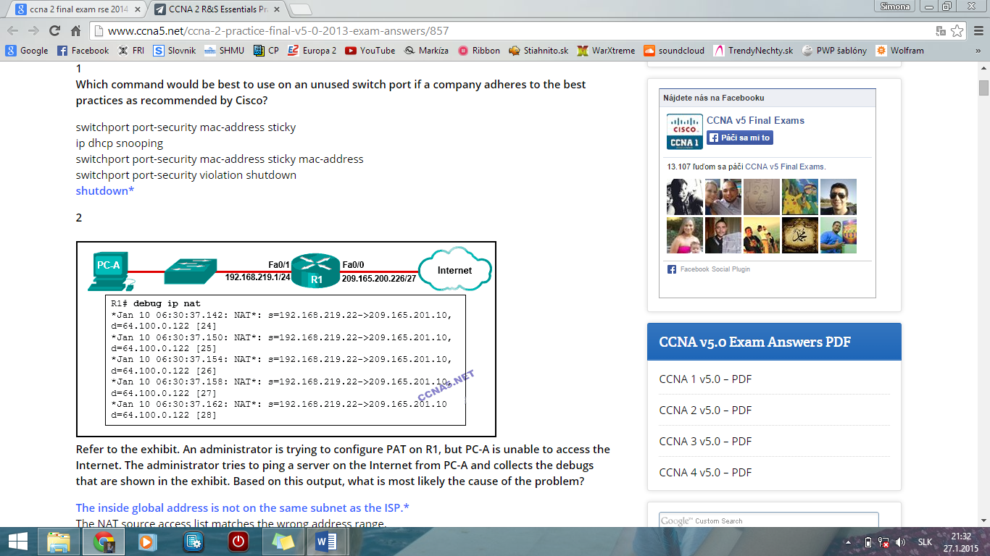  
**Refer to the exhibit. An administrator is trying to configure PAT on R1, but PC-A is unable to access the Internet. The administrator tries to ping a server on the Internet from PC-A and collects the debugs that are shown in the exhibit. Based on this output, what is most likely the cause of the problem?**  
**The inside global address is not on the same subnet as the ISP.\***

**3 A small company has a web server in the office that is accessible from the Internet. The IP address 192.168.10.15 is assigned to the web server. The network administrator is configuring the router so that external clients can access the web server over the Internet. Which item is required in the NAT configuration?**  
**the ip nat inside source command to link the inside local and inside global addresses\***

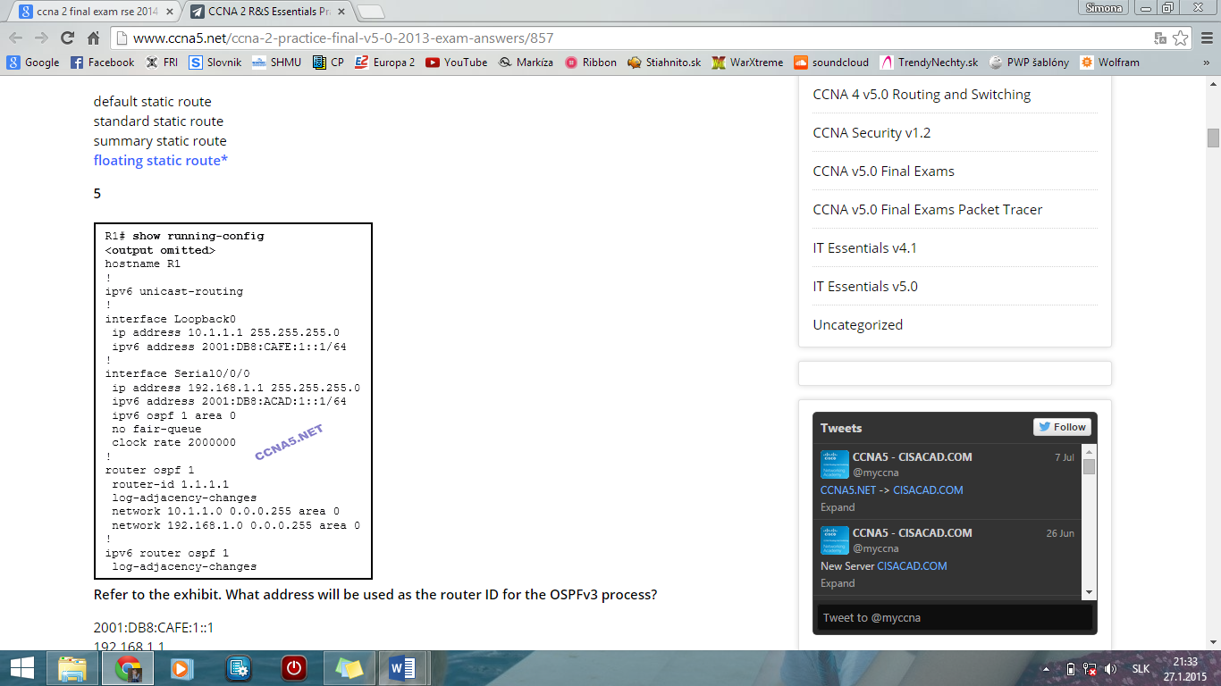**4 Which type of static route typically uses the distance parameter in the ip route global configuration command?**  
**floating static route\***

**5** **Refer to the exhibit. What address will be used as the router ID for the OSPFv3 process?**  
**10.1.1.1\***

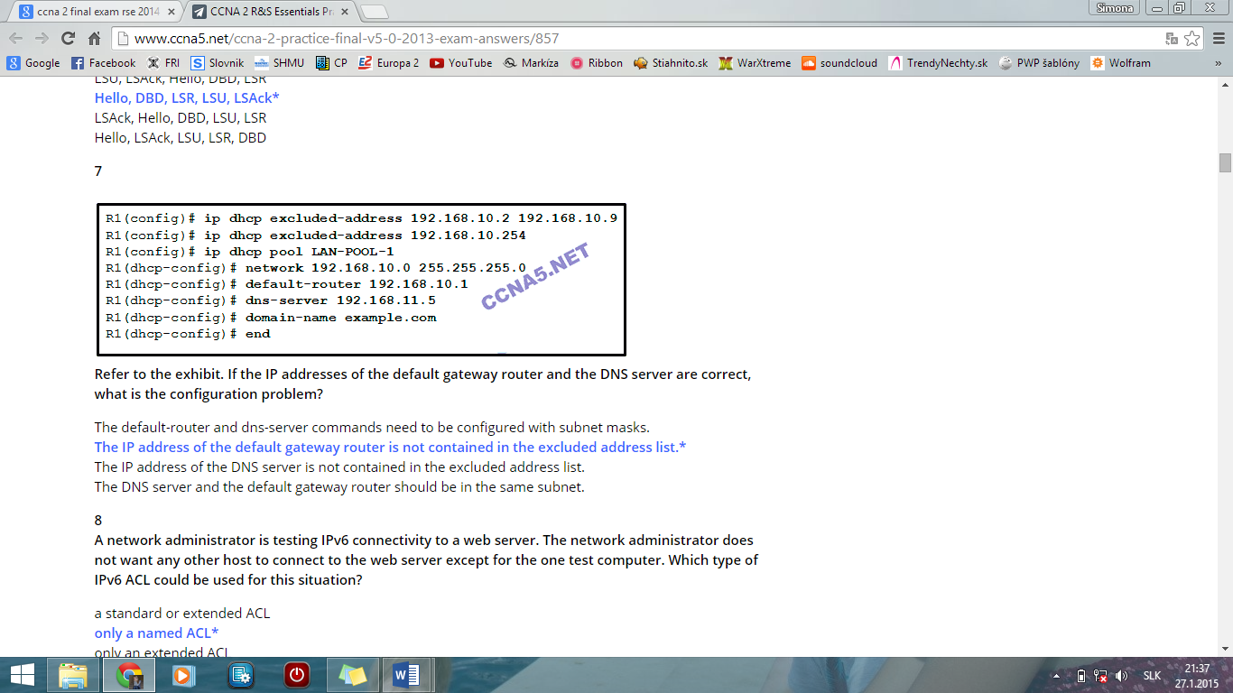  
**6 What is the order of packet types used by an OSPF router to establish convergence?**  
**Hello, DBD, LSR, LSU, LSAck\***

**7** **Refer to the exhibit. If the IP addresses of the default gateway router and the DNS server are correct, what is the configuration problem?**  
**The IP address of the default gateway router is not contained in the excluded address list.\***

**8 A network administrator is testing IPv6 connectivity to a web server. The network administrator does not want any other host to connect to the web server except for the one test computer. Which type of IPv6 ACL could be used for this situation?**  
**only a named ACL\***

**9**

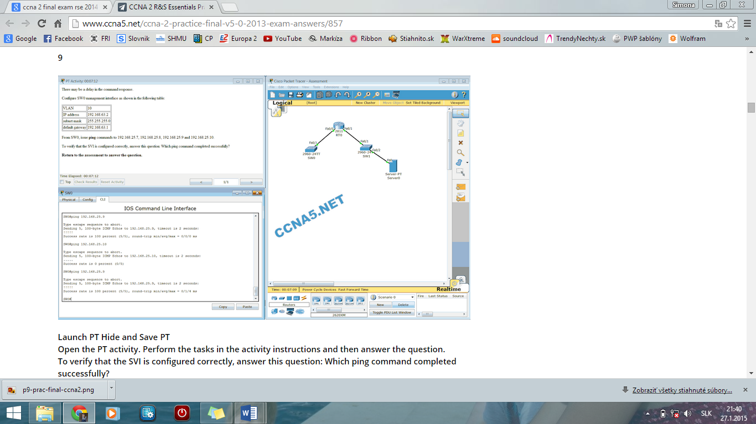

**Launch PT Hide and Save PT**  
**Open the PT activity. Perform the tasks in the activity instructions and then answer the question.**  
**To verify that the SVI is configured correctly, answer this question: Which ping command completed successfully?​**  
**ping 192.168.25.9\***  
**CONFIGURATION**

SW0(config)#**interface vlan 10**  
SW0(config-if)#**ip address 192.168.63.2 255.255.255.0**  
SW0(config-if)#**exit**  
SW0(config)#**ip default-gateway 192.168.63.1**  
SW0(config)#**end**

**10 What is an advantage of using dynamic routing protocols instead of static routing?**  
**ability to actively search for new routes if the current path becomes unavailable​\***

**11 How many classful networks are summarized by the static summary route ip route 192.168.32.0 255.255.248.0 S0/0/0?**  
**8\***

**12 Which switching method provides error-free data transmission?**  
**store-and-forward\***

**13 A client is using SLAAC to obtain an IPv6 address for its interface. After an address has been generated and applied to the interface, what must the client do before it can begin to use this IPv6 address?**  
**It must send an ICMPv6 Neighbor Solicitation message to ensure that the address is not already in use on the network.\***

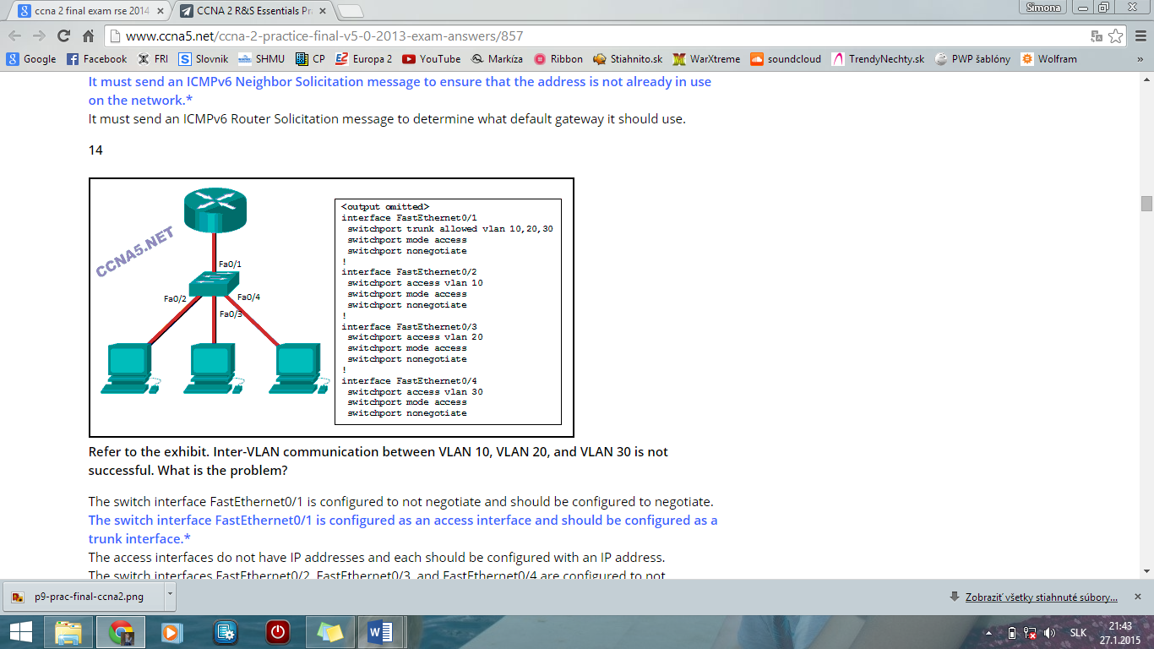**14** **Refer to the exhibit. Inter-VLAN communication between VLAN 10, VLAN 20, and VLAN 30 is not successful. What is the problem?**  
**The switch interface FastEthernet0/1 is configured as an access interface and should be configured as a trunk interface.\***

**15 Which network design may be recommended for a small campus site that consists of a single building with a few users?**  
**a collapsed core network design\***

**16 How is the router ID for an OSPFv3 router determined?**  
**the highest IPv4 address on an active interface\***

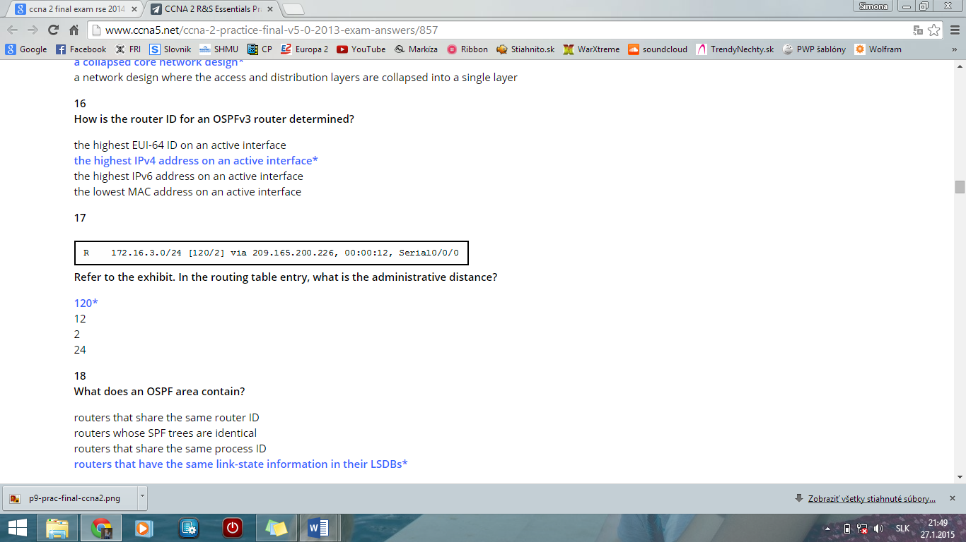

**17**  
 **Refer to the exhibit. In the routing table entry, what is the administrative distance?**  
**120\***

**18 What does an OSPF area contain?**  
**routers that have the same link-state information in their LSDBs\***

**19 Which command will create a static default route on R1 to send all traffic to the Internet and use serial 0/0 as the exit interface?**  
**R1(config)# ip route 0.0.0.0 0.0.0.0 serial 0/0\***

**20 What is a result of connecting two or more switches together?**  
**The size of the broadcast domain is increased.\***

**21 Which DHCP IPv4 message contains the following information?**

**Destination address: 255.255.255.255**  
**Client IPv4 address: 0.0.0.0**  
**Default gateway address: 0.0.0.0**  
**Subnet mask: 0.0.0.0**  
**DHCPDISCOVER\***

**22 What is meant by the term “best match” when applied to the routing table lookup process?**  
**longest match\***

**23 Fill in the blank.**  
Using router-on-a-stick inter-VLAN routing, how many subinterfaces have to be configured to support 10 VLANs?​ ” **10**”

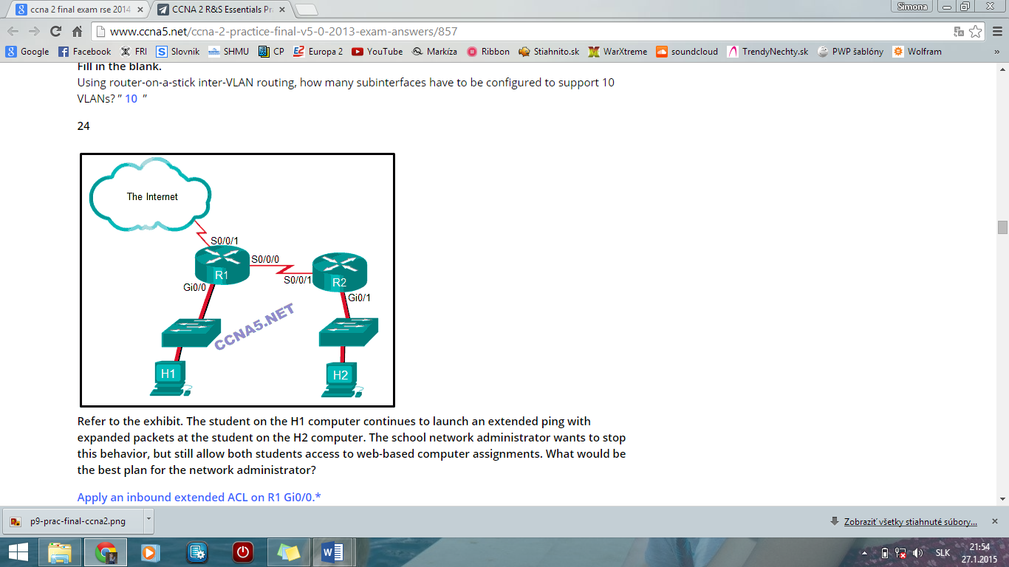**24**

**Refer to the exhibit. The student on the H1 computer continues to launch an extended ping with expanded packets at the student on the H2 computer. The school network administrator wants to stop this behavior, but still allow both students access to web-based computer assignments. What would be the best plan for the network administrator?**  
**Apply an inbound extended ACL on R1 Gi0/0.\***

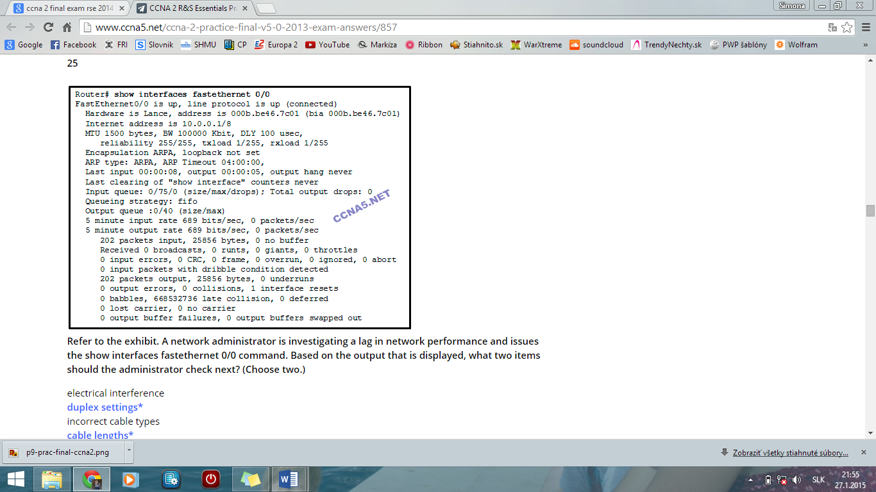**25**  
**Refer to the exhibit. A network administrator is investigating a lag in network performance and issues the show interfaces fastethernet 0/0 command. Based on the output that is displayed, what two items should the administrator check next? (Choose two.)**  
**duplex settings\***  
**cable lengths\***

**26**

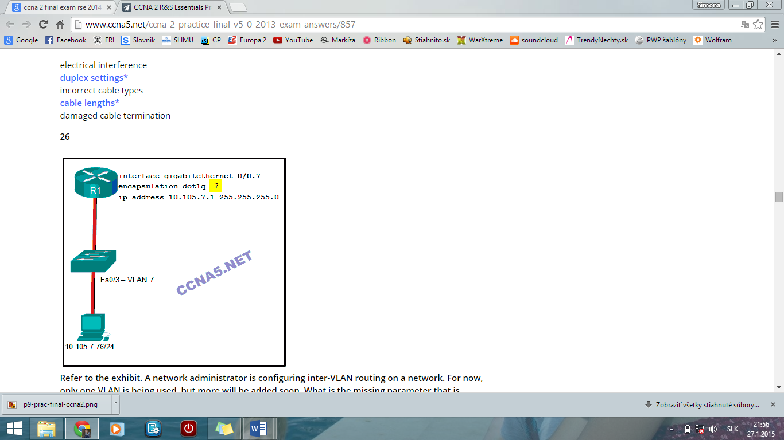  
**Refer to the exhibit. A network administrator is configuring inter-VLAN routing on a network. For now, only one VLAN is being used, but more will be added soon. What is the missing parameter that is shown as the highlighted question mark in the graphic?**  
**It identifies the VLAN number.\***

**27**

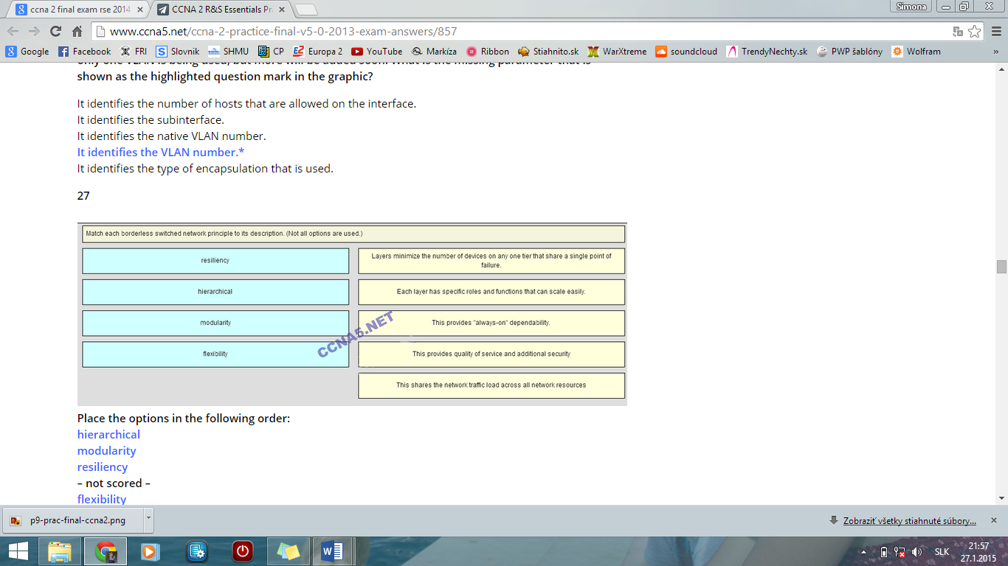  
**Place the options in the following order:**  
**hierarchical**  
**modularity**  
**resiliency**  
**– not scored –**  
**flexibility**

**28 Which command will verify the status of both the physical and the virtual interfaces on a switch?**  
**show ip interface brief\***

**29**

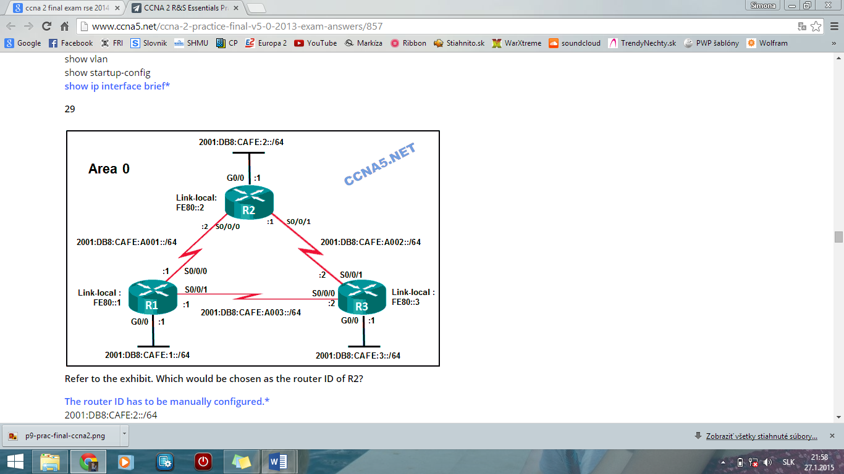  
**Refer to the exhibit. Which would be chosen as the router ID of R2?**  
**The router ID has to be manually configured.\***

**30 A router with two LAN interfaces, two WAN interfaces, and one configured loopback interface is operating with OSPF as its routing protocol. What does the router OSPF process use to assign the router ID?**  
**the loopback interface IP address\***

**31 Which two pieces of information are required when creating a standard access control list? (Choose two.)**  
**source address and wildcard mask\***  
**access list number between 1 and 99\***

**32 What is the effect of the access control list wildcard mask 0.0.0.15? (Choose two.)**  
**The first 28 bits of a supplied IP address will be matched.\***  
**The last four bits of a supplied IP address will be ignored.\***  
  
**33 A college student is studying for the Cisco CCENT certification and is visualizing extended access lists. Which three keywords could immediately follow the keywords permit or deny as part of an extended access list? (Choose three.)**  
**udp\***  
**tcp\***  
**icmp\***

**34 Which two keywords can be used in an access control list to replace a wildcard mask or address and wildcard mask pair? (Choose two.)**  
**any\***  
**host\***

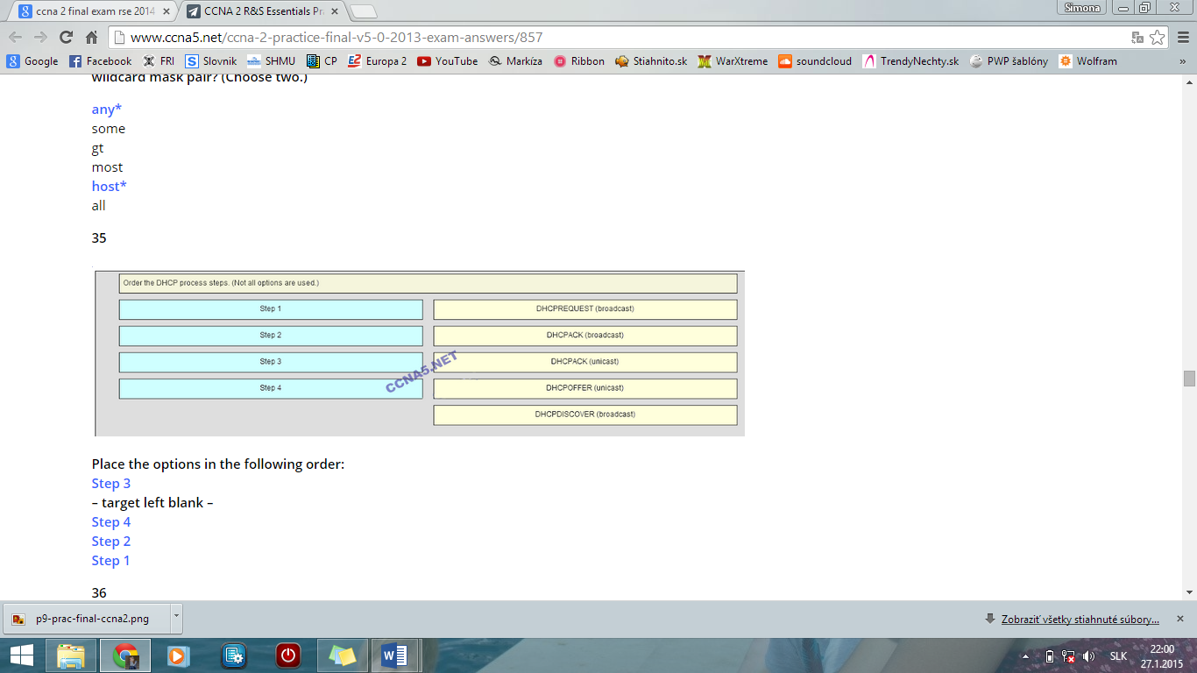**35**

**Place the options in the following order:**  
**Step 3**  
**– target left blank –**  
**Step 4**  
**Step 2**  
**Step 1**

**36 Fill in the blank. Do not use abbreviations.**  
The “**duplex full**” command configures a switch port to operate in the full-duplex mode.

**37**

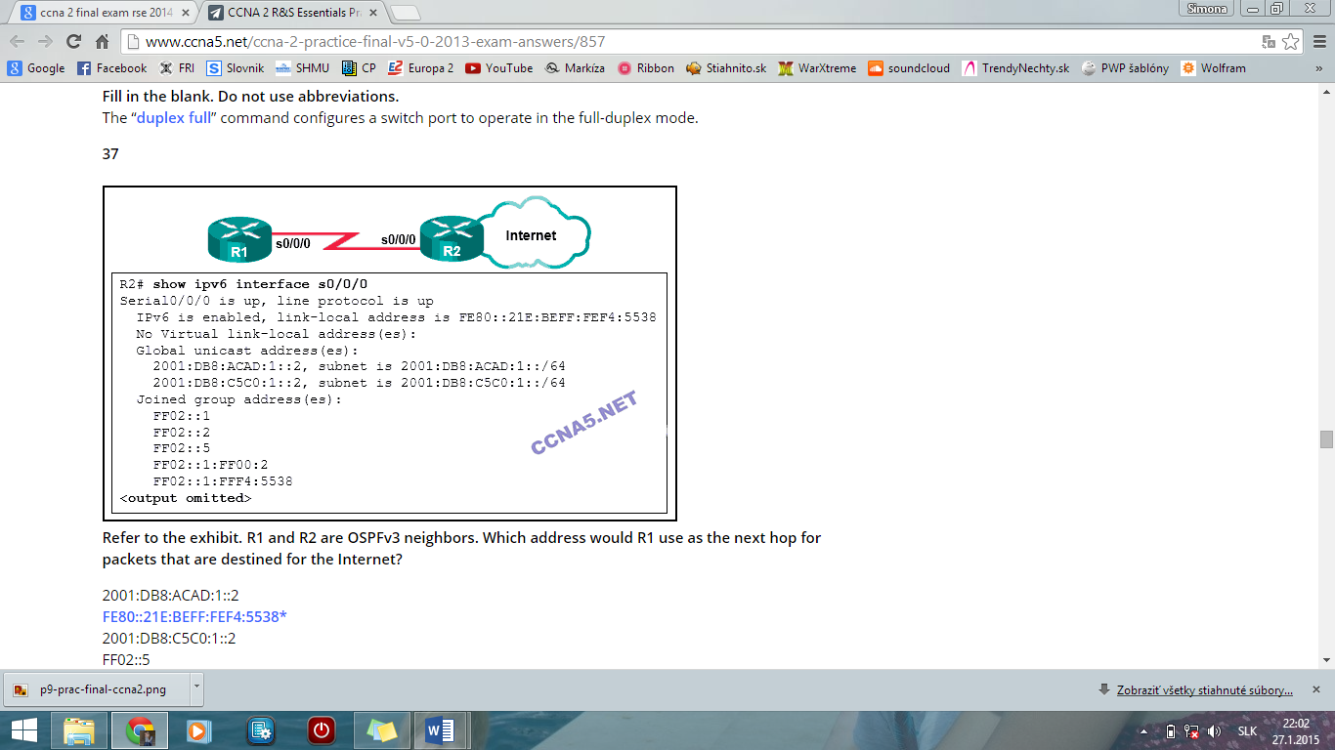  
**Refer to the exhibit. R1 and R2 are OSPFv3 neighbors. Which address would R1 use as the next hop for packets that are destined for the Internet?**  
**FE80::21E:BEFF:FEF4:5538\***

**38 In a routing table which route can never be an ultimate route?**  
**parent route\***

**39**

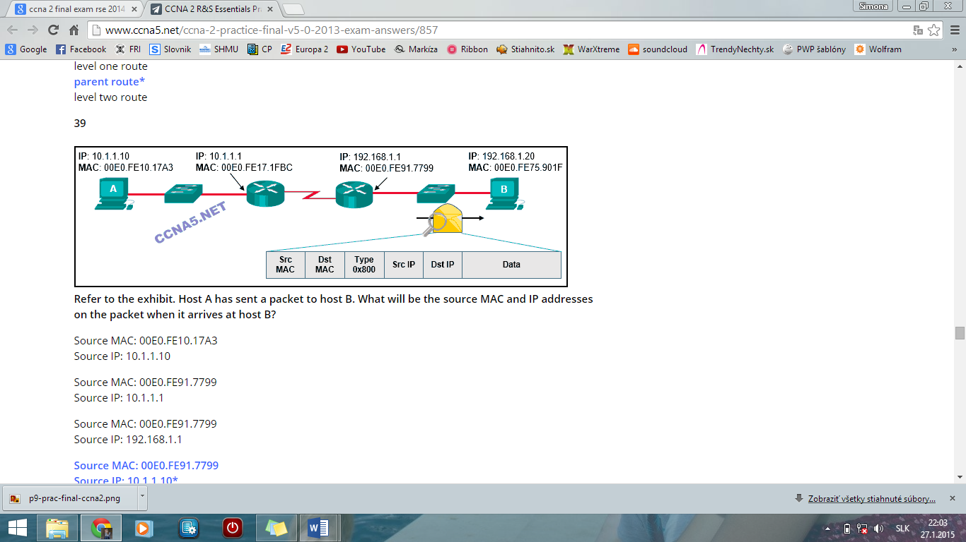  
**Refer to the exhibit. Host A has sent a packet to host B. What will be the source MAC and IP addresses on the packet when it arrives at host B?**  
**Source MAC: 00E0.FE91.7799**  
**Source IP: 10.1.1.10\***

**40 What is the effect of entering the network 192.168.10.1 0.0.0.0 area 0 command in router configuration mode?**  
**OSPF advertisements will include the network on the interface with the IPv4 address 192.168.10.1.\***

**41 An administrator is trying to remove configurations from a switch. After using the command erase startup-config and reloading the switch, the administrator finds that VLANs 10 and 100 still exist on the switch. Why were these VLANs not removed?**  
**Because these VLANs are stored in a file that is called vlan.dat that is located in flash memory, this file must be manually deleted.\***

**42 What is a disadvantage when both sides of a communication use PAT?**  
**End-to-end IPv4 traceability is lost.\***

**43 What is associated with link-state routing protocols?**  
**shortest-path first calculations\***

**44**

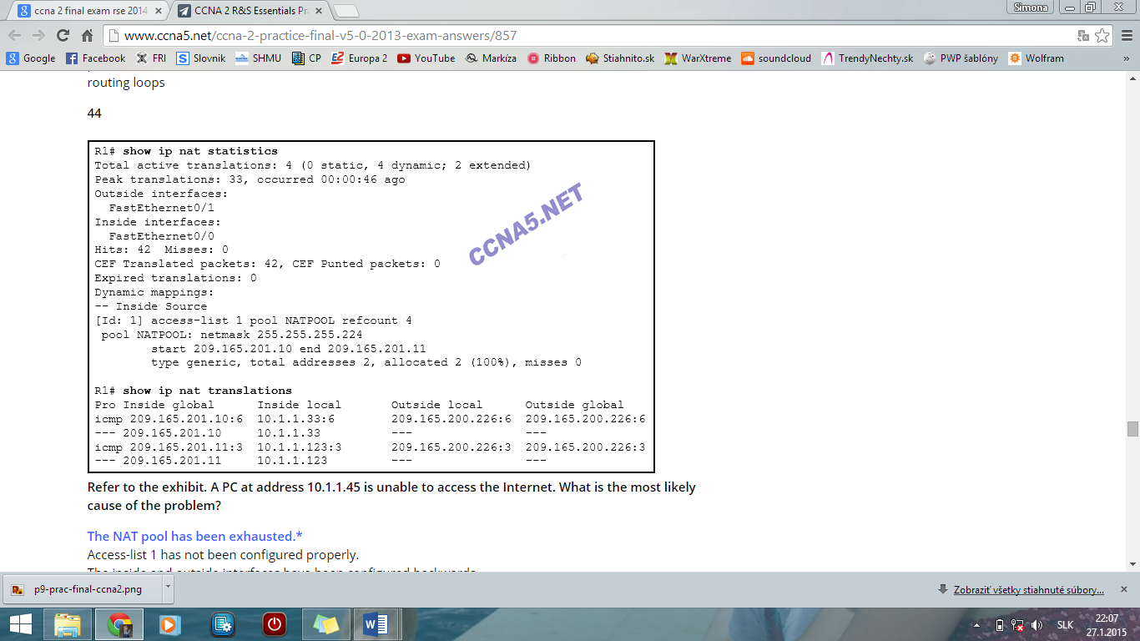  
**Refer to the exhibit. A PC at address 10.1.1.45 is unable to access the Internet. What is the most likely cause of the problem?**  
**The NAT pool has been exhausted.\***  
**45 In which type of attack does a malicious node request all available IP addresses in the address pool of a DHCP server in order to prevent legitimate hosts from obtaining network access?​  
DHCP starvation\***

**46 When does a switch use frame filtering?**  
**The destination MAC address is for a host on the same network segment as the source of the traffic.\***

**47 How will a router handle static routing differently if Cisco Express Forwarding is disabled?**  
**Ethernet multiaccess interfaces will require fully specified static routes to avoid routing inconsistencies.\***

**48 An administrator created and applied an outbound Telnet extended ACL on a router to prevent router-initiated Telnet sessions. What is a consequence of this configuration?**  
**The ACL will not work as desired because an outbound ACL cannot block router-initiated traffic.\***

**49 An administrator attempts to change the router ID on a router that is running OSPFv3 by changing the IPv4 address on the router loopback interface. Once the IPv4 address is changed, the administrator notes that the router ID did not change. What two actions can the administrator take so that the router will use the new IPv4 address as the router ID? (Choose two.)**  
**Reboot the router.\***   
**Clear the IPv6 OSPF process.\***

**50 When routing a large number of VLANs, what are two disadvantages of using the router-on-a-stick inter-VLAN routing method rather than the multilayer switch inter-VLAN routing method? (Choose two.)**  
**A dedicated router is required.\***  
**Multiple subinterfaces may impact the traffic flow speed.\***